Job Application Tracking System

# Introduction:

## Overview:

The job application tracking system is software for recruiters and employers to track candidates throughout the recruiting and hiring process.

## Purpose:

The job application tracking system often referred to as an ATS, is a software application that automates the hiring process. Job application tracking system solutions organize and streamline the hiring process from source to hire.

# Problem Definition & Design Thinking:

* 1. **Empathy Map:**

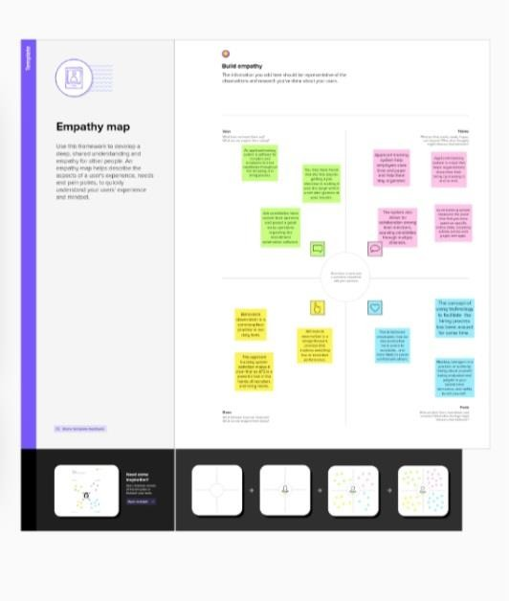

* 1. **Ideation & Brainstorming Map:**

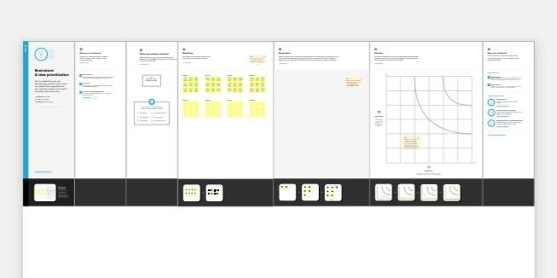

# Result:

* 1. **Data Model:**

|  |  |  |  |  |
| --- | --- | --- | --- | --- |
| **Object Name** | **Fields In The Object** | | | |
| **Jobs** |  | **Field Label** | **Data Type** |  |
| Job title | Text |  |
| Recruiters | Master-detail  relationship |  |
| Description | Text area |  |
| Location | Text |  |

* 1. **Activity & Screenshot:**

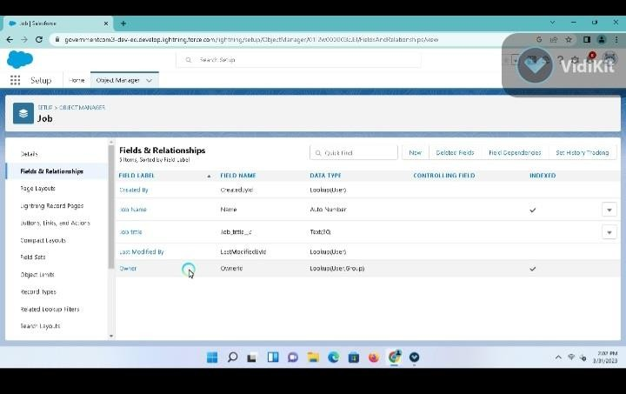

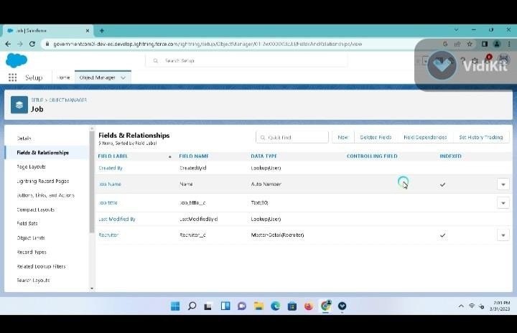

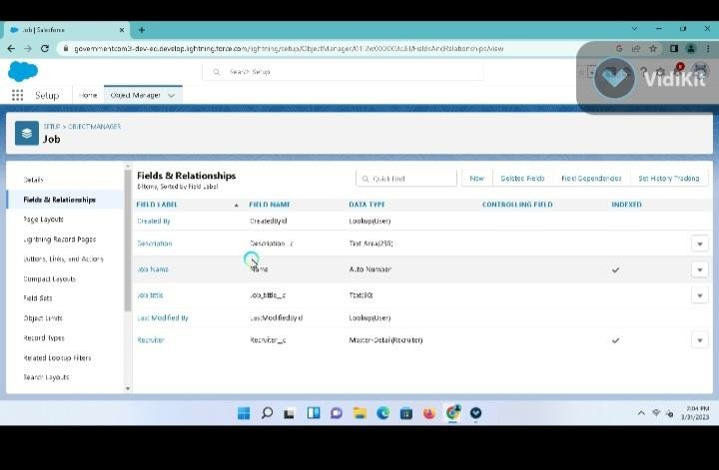

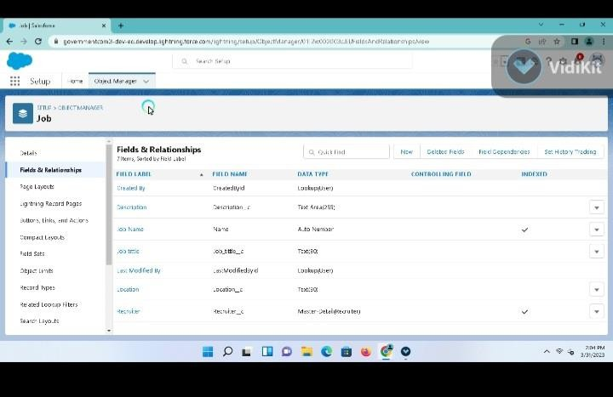

# Trailhead Profile Public URL:

**Team Leader: https://trailblazer.me/id/kavim44**

**Team Member 1:** [**https://trailblazer.me/id/**](https://trailblazer.me/id/rlakshmin4)**mrethinam1**

**Team Member 2:** [**https://trailblazer.me/id/**](https://trailblazer.me/id/raksb10)**pletchumy**

**Team Member 3:** [**https://trailblazer.me/id/**](https://trailblazer.me/id/sasim32)**priyam6**

# Advantages:

* Streamlines recruiting.
* Posts Jobs on multiple job boards.

*Saves time by automating mundane tasks.

*Builds your brand.

*Manages talent database.

# Disadvantages:

**\***A disadvantages of ATS is missing qualified applicants do you do wrong keyword selection.

*Automatic elimination of resumes that software can’t recognize and interpret is another drawback

ATS .

*An applicant tracking system disadvantage is that they are open to manipulation.

# Applications:

**\***Yard management.

*Fleet management.

*Person tracking.

*GPS tracking.

*Real-time locating system.

# Conclusion:

Job application tracking system for recruiters is a very effective hiring solution that most of the successful recruiters utilize. Because without it, there is a good chance that your process of moving applicants through different stages can become very difficult.

# Future Goals:

The job application tracking system creates opportunities to automate manual processes, increase visibility into the hiring cycle for the entire recruiting team, and increase opportunities for communication throughout the candidate journey. 78% of recruiters using an ATS report that it has improved the quality of the candidates they hire.